**OBSTACLE AVOIDING ROBOT**

By: Rakshith Rupanagudi

Under Prof: Fernando Vilarino (UAB)

Table of Contents:

|  |  |  |
| --- | --- | --- |
| Sl.No. | Content | Page No. |
| 1 | Ideology behind the Screens | 1 |
| 2 | Components | 1 |
| 2.1 | Microcontroller | 1 |
| 2.2 | Ultrasonic Sensor | 2 |
| 2.3 | Servo Motor | 2 |
| 2.4 | Motor Driver | 3 |
| 2.5 | DC motors, Bread Board, Jumper Wires | 3 |
| 3 | Fritzing Diagram | 4 |
| 4 | Software Architectural Diagram | 5 |
| 5 | Robot Chassis Design Layout | 5 |
| 6 | Connections | 6 |
| 7 | Advantages | 7 |
| 8 | Applications | 7 |

**1. Ideology behind the screens:**

Technology is taking the front edge in the globalization of the digital world. Robotics, the future sun of technology is the art of reducing human effort. Meanwhile, one more technology emerging is the automation. The collaboration of both locomotive robotics and automation is our project. We use a microcontroller in controlling the action of robot. With the help of an ultrasonic sensor we measure the distance. The ultrasonic sensor is basically a transducer which converts the time into distance. It uses the principle of reflection finding out the obstacle. The sensor is basically a transducer, which converts travel time into distance. The biggest advantage of this project is that it reduces human effort. Furtherly, in future we want to implement this project model on a large scale by the means of google maps for real time needs which leads to the development of driverless vehicles.

**2. Components Required:**

**2.1 Arduino Nano (Microcontroller)**

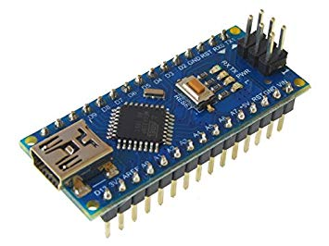

Arduino Nano is a microcontroller which is derived from the family of Atmega 328; a product of the company Atmel Electronics. Basically a microcontroller is a user friendly electronic device which is generally used to perform a specific task. Here, task may be either one time or an infinite number of times, it is user controllable. User will have to code the required task in the form of an assembly language (or language with effective to the microcontroller, mostly a high level language). The Microcontroller converts the code written into its understandable language and performs the task as per the code written by the user.

* 1. **Ultrasonic Sensor(HCSR04):**

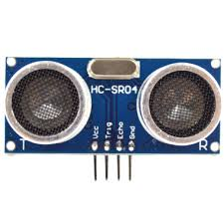

An Ultrasonic sensor is used to measure distance of any object which is near to it or approaching it. As mentioned above, it is a transducer which converts time of light travelling to and fro into distance in centimetres or inches. It has three main units which are, the transmitting unit, the receiving unit, and the controlling unit. The transmitting unit transmits the light on a trigger obtained through the trigger pin of the sensor. The trigger is basically obtained from one of the pins of the microcontroller. On transmitting, the light obviously meets some object which indeed reflects the light back. Now the receiving unit is active in sensing the reflected light back. The control unit thus receives the data from the receiving unit in the form of time. The distance is computed by the control unit as follows:

Distance= time of travel * velocity of light.

Note: The transmitting and receiving units are active in work only when the light travelled is of the same range approximately. If the received signal is not in range with the transmitted signal the control unit is not driven to work.

* 1. **Servo Motor(MG996R):**

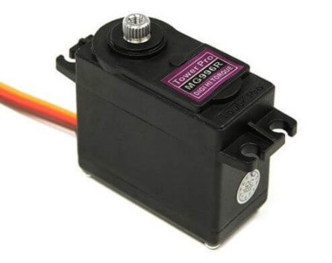

A Servo motor is a closed loop control system indeed a rotary controllable device. It is basically a motor whose principle is converting electrical energy into mechanical form. The speciality of this device it controls the motor’s rotary movement based on angular scale (like 0° to 360°) and the velocity, acceleration. It is a closed loop control system. There are two units in main one the control unit and the other the feedback unit. The control unit is a specialized electric brain which controls the motor’s action. It does all the control action on the basis of arguments received from the feedback unit. The feedback unit is designed such that it uses various sensors like potentiometer to keep the track of elements like distance, angle, velocity, acceleration. The feedback unit eliminates the noise and passes data to the control unit. The control unit finds the difference (precisely speaking error) and performs the required so as to compensate the difference.

* 1. **Motor Driver (L298N):**

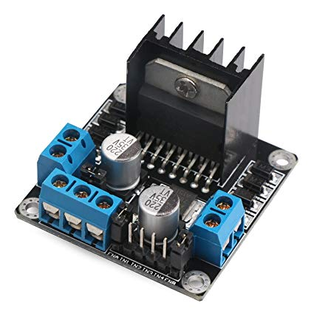

Motor driver is an electronic device which comes into picture when the voltage to drive motors is insufficient. The working of motors is possible only when the voltage is sufficient. If Arduino is used we power it up with voltage of 3.3 V, which is deficient for the motors to run. A motor driver uses this voltage by regulating, amplifying and supplying it to the motors. It has three units mainly the input unit, output unit and the control unit. Input unit takes the input from the microcontroller and gives it to the control unit. Control unit regulates, amplifies and supplies the voltage to the output unit. The output unit drives the motors.

* 1. **DC Motors:**

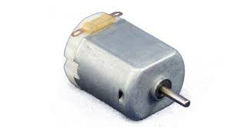

DC motors are electromechanical devices which convert electrical energy into mechanical form. It is polarity sensitive. To obtain the reverse movement we need to reverse the polarity.

**Bread Board:**

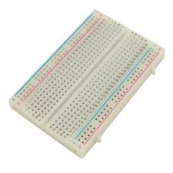

Bread Board is an electric junction contact which is basically the wiring of the conductors all over it in order to perform electronic operations.

**Jumper Wires:**

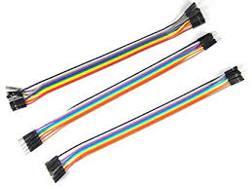

**3. FRTIZING DIAGRAM**

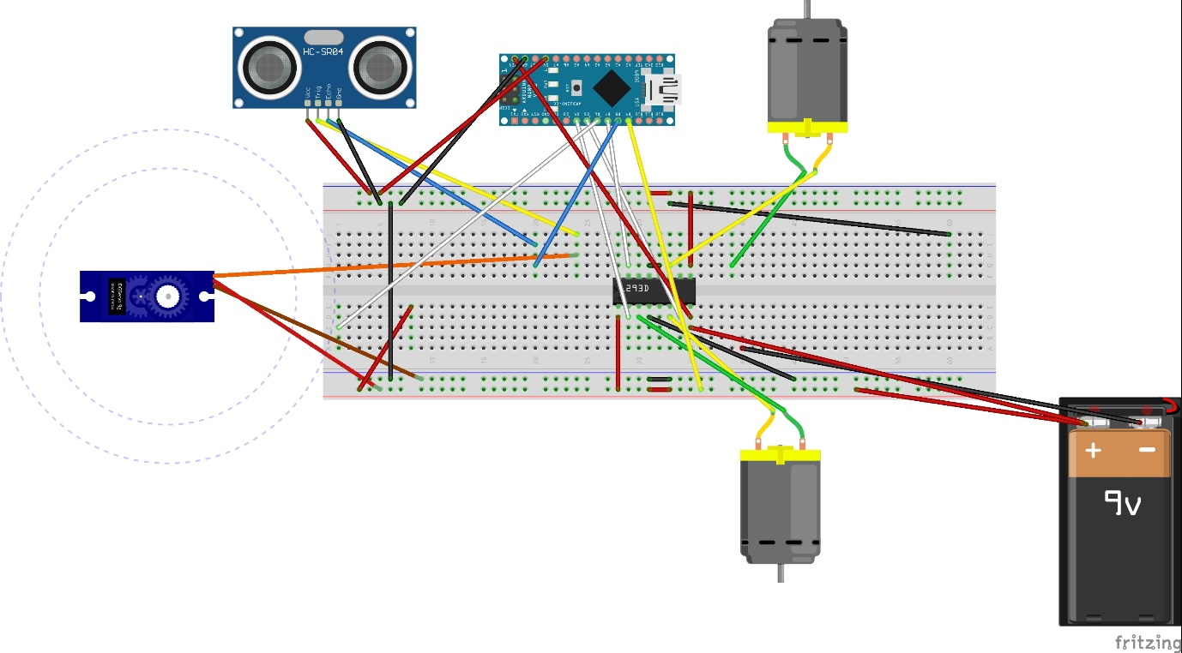

**4. SOFTWARE ARCHITECTURE DIAGRAM**

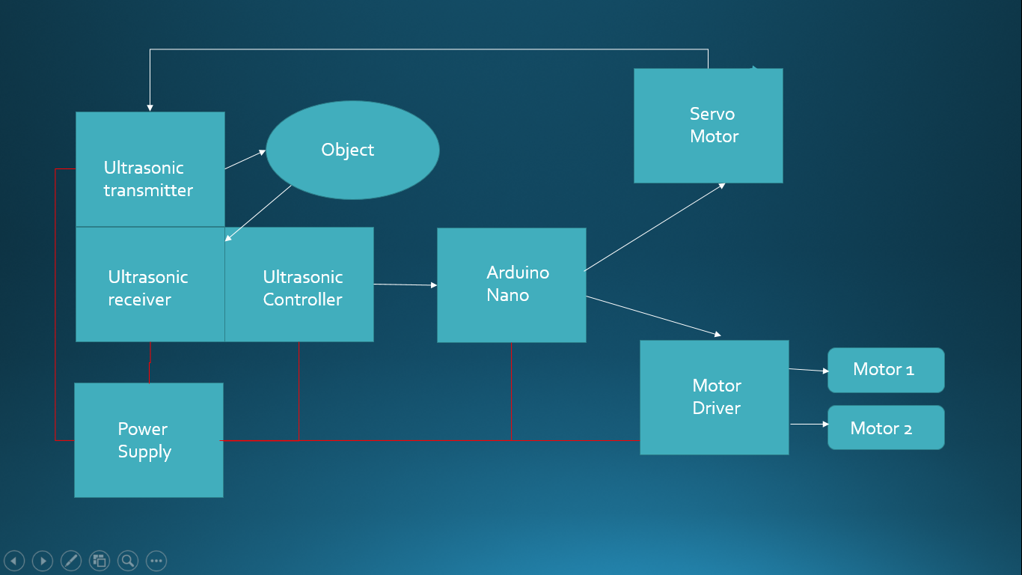

**5. Robot Chassis Design Layout**

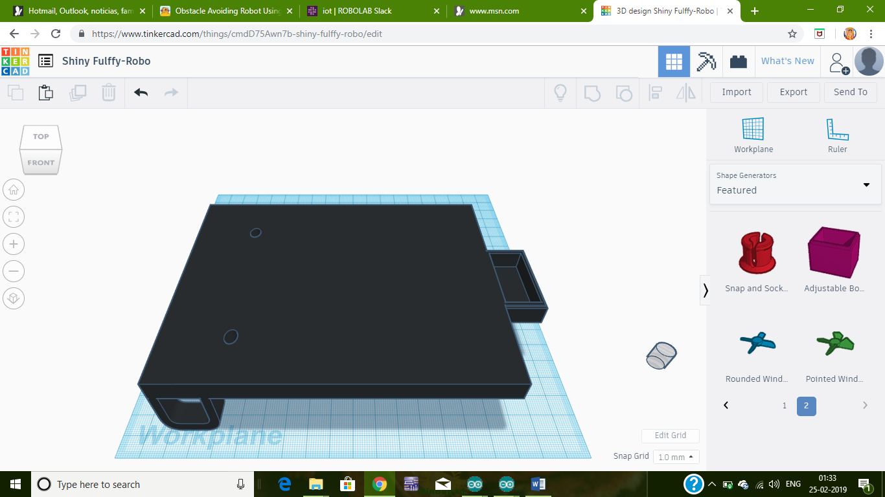

**6. Connections:**

***Arduino Nano:***

5V to +ve of Battery

Gnd to –ve of Battery

D4 to IN1 of motor driver

D5 to IN2 of motor driver

D6 to IN3 of motor driver

D7 to IN4 of motor driver

D8 to echo pin of Sensor

D9 to trigger pin of sensor

***Motor Driver:***

EN1 and EN2 to V in of Nano

OUT1 and OUT2 to motor1

OUT3 and OUT4 to motor2

VCC to +ve of battery

Gnd to –ve of Battery

***Servo Motor:***

VCC to +ve of battery

Gnd to –ve of battery

IN to trig of sensor

***Sensor:***

VCC to +ve of battery

GND to –ve of battery

**Working:**

The sensor senses the time and converts it into distance. The distance now in the Arduino code is set with a threshold value say 25 cm. If the distance is greater than the threshold the motor driver activates the motors to move in forward direction. If the distance measured is lesser than the threshold then the servo motor changes the left dc motor backwards and the right motor runs forward such that the rotation is in right direction deviating from the obstacle. Thus resulting in the obstacle avoidance.

**7. Advantages:**

1. It is automatic, no requirement of human power.
2. Efficient with very less delay.

**8. Applications:**

1. Driverless automobiles.
2. Integration with voice controlled auto-mobiles .